# Lab: Unit Testing

# Unit Testing Basics

## Test Axe

Create a class AxeTests

Create the following tests:

* Test if weapon loses durability after each attack
* Test attacking with a broken weapon

### Solution

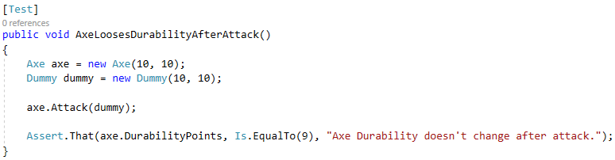

## Test Dummy

Create a class DummyTests

Create the following tests:

* Dummy loses health if attacked
* Dead Dummy throws exception if attacked
* Dead Dummy can give XP
* Alive Dummy can't give XP

### Hints

Follow the logic of the previous problem

ABroke